Chapter 15, Problem 43.

Find y(t) = x(t)*h(t) for each paired x(t) and h(t) in Fig. 15.37.

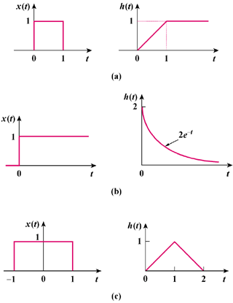

Figure 15.37
For Prob. 15.43.

